New Regression

Nam Tran

Packages used

pacman::p_load(tidyverse,   
 magrittr,  
 skimr,  
 psych,  
 broom)  
options(scipen = 999)

# Data Preparation

Import the full data to the working environment

full_data <- read.csv('full_data.csv', stringsAsFactors = T)

Convert PERMNO to factor and format the date column

full_data %<>%  
 select(-X) %>%   
 mutate(PERMNO = as.factor(PERMNO),  
 date = ymd(date)  
 )

# Period 1

Extract data for the first period only

sample_1 <- full_data %>%   
 filter(year %in% c(2016, 2017, 2018)) %>%   
 select(everything())

# Customization Function

## 1. Model Execution

model_execution <- function(data){  
 # Create an empty data frame to store the results  
 results <- data.frame(PERMNO = character(),  
 Reg1_B1 = numeric(),  
 Reg1_P1 = numeric(),  
 Reg1_ARS = numeric(),  
 stringsAsFactors = T)  
   
 # Loop through all unique company names  
 for (company in unique(data[,'PERMNO'])) {  
 # Filter the data for the current company  
 company_data <- data %>%  
 filter(PERMNO == company)  
   
 # Create a linear regression model with the constraint on the intercept  
 model <- lm(excess_ret ~ 0 + market_prem,   
 data = company_data)  
   
 # Extract the coefficient values, p-values, and adjusted R-squared  
 coefficient <- coef(model)["market_prem"]  
 p_value <- summary(model)$coefficients["market_prem",   
 "Pr(>|t|)"]  
 adjusted_r_squared <- summary(model)$adj.r.squared  
   
 # Store the extracted values in the results data frame  
 results <- rbind(results,   
 data.frame(PERMNO = company,  
 Reg1_B1 = coefficient,  
 Reg1_P1 = p_value,  
 Reg1_ARS = adjusted_r_squared,  
 stringsAsFactors = T))  
 rownames(results) <- NULL  
   
 # Round output to 4 decimal places  
 results %<>%   
 mutate_if(is.numeric, round, digits = 4)  
 }  
 return(results)  
  
}

## 2. Statistical summary

statistic_summary <- function(data){  
  
 train_1 %>%   
 select(-PERMNO) %>%   
 describe() %>%   
 select(mean, sd, skew, kurtosis)  
}

## 3. Visualization

histogram_viz <- function(input, variable, binwdith = 0.05, time){  
 input %>%  
 ggplot(aes_string(x = variable)) +  
 geom_histogram(binwidth = binwdith, fill = "#5DADE2", color = "#2C3E50", alpha = 0.8) +  
 labs(title = paste("Distribution of", variable, time),  
 x = variable,  
 y = "Frequency") +  
 theme_minimal() +  
 theme(plot.title = element_text(hjust = 0.5, size = 12, face = "bold"),  
 axis.title.x = element_text(size = 10, face = "bold"),  
 axis.title.y = element_text(size = 10, face = "bold"),  
 axis.text = element_text(size = 8))  
}

## Model 1: Stock’s Excess Return ~ Unadjusted Market Return

### 1. Model’s Execution

train_1 <- model_execution(sample_1)  
  
# Sample Result  
train_1 %>% head()

PERMNO Reg1_B1 Reg1_P1 Reg1_ARS  
1 10104 1.0007 0 0.3815  
2 10107 1.3631 0 0.6133  
3 10138 1.2792 0 0.5538  
4 10145 0.9291 0 0.5516  
5 10516 0.8986 0 0.2653  
6 10696 0.8886 0 0.4528

### 2. Statistical Summary

train_1_summary <- statistic_summary(train_1)

### 3. Visualization

histogram_viz(train_1,   
 variable = 'Reg1_B1',  
 time = 'from 2016 to 2018')

Warning: `aes_string()` was deprecated in ggplot2 3.0.0.  
ℹ Please use tidy evaluation ideoms with `aes()`

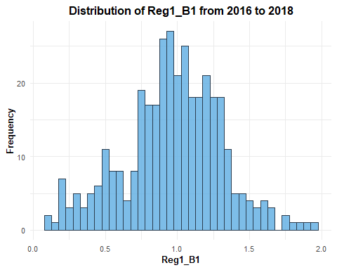

histogram_viz(train_1, variable = 'Reg1_ARS',   
 binwdith = 0.015,  
 time = 'from 2016 to 2018')

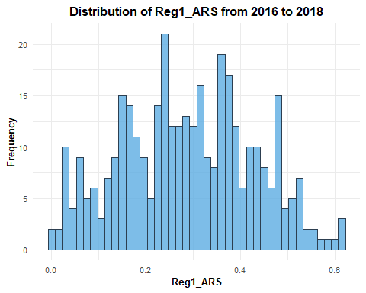

# Period 2

Change the sub sample dataset

sample_2 <- anti_join(full_data, sample_1, by = 'date')

## Model 1: Stock’s Excess return ~ Market Premium

### 1. Model’s Execution

validation_1 <- model_execution(sample_2)

### 2. Statistical Summary

valid_1_summary <- statistic_summary(validation_1)

### 3. Visualization

histogram_viz(validation_1,   
 variable = 'Reg1_B1',   
 time = 'From 2019 to 2021')

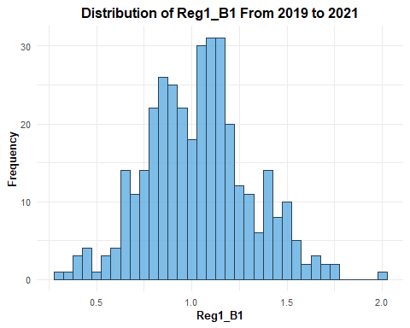

histogram_viz(validation_1, 'Reg1_ARS',   
 binwdith = 0.015,  
 'From 2019 to 2021')

